Manual Instruction for

Weighing machine touchpanel – terminal

Only for the AKE 2-4 units

side menu description

3 POWER ON Power on menu
3-5 KEYWORD password menu
6 DATA/TIME change date and time
7 CONFIG change windows settings
8 LANGUAGE change language
9 BACKUP backup and restore setting - files
10-11 UPDATE SERVER programme update
12 UPDATE CLIENTS ! not for AKE-Units !
13 INITIALISIERUNG weighing machine initialization
14 MACHINE start weighing-programme
15 COUNTER set shedding-counter
16-17 OPERATING MODE set/charge operating mode
18 RECIPES database of recipes
19-20 - COPY copy recipes
21-22 - EDIT edit recipes
23 - DELETE delete recipe
24 - SEARCHING searching recipe with number
25 - SEARCH PRODUCTNAME searching recipe with name
26 TARE SETTINGS change tare-settings
27 CHANGE DELAYS change delay-times
28 SUPPLY SETTINGS change supply-settings
29 REFERENCES SETTINGS change reference values
30 TARE tare weighing head
31 EMPTY empty weighing line or weighing bowl
32 ON-OFF weighing line switch ON or OFF
33 ACTIVITY ADVERTISEMENT
34 CONTROL FUNCTIONS weighing head, input, output controls
35 WEIGH. HEAD CONTROL weighing head control
36 INPUT-OUTPUT CONTROL input, output control
37 OPTIONS setting optional functions
38-39 TOUCHPANEL CALIBRATION Calibration the touchpanel
40 NOTIZE TO INITIALIZATION read me !
41-42 NOTIZE TO OPTIMATION description of Optimation

Menu-s

- Power-on menu

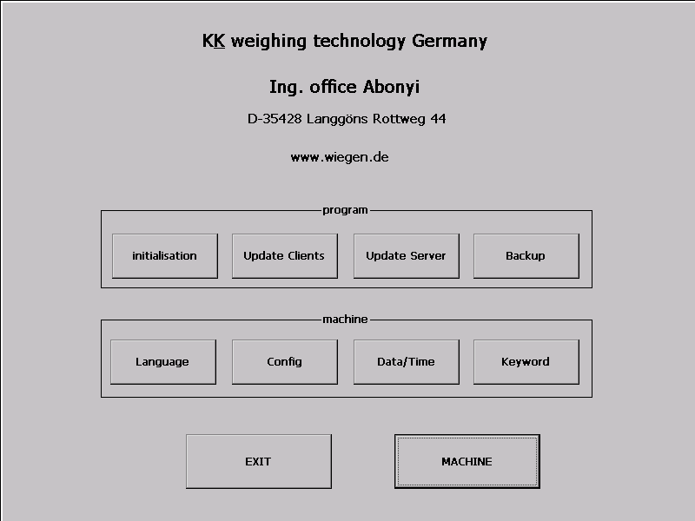

Only the button KEYWORD is active!
( using another button , you will get an error message )

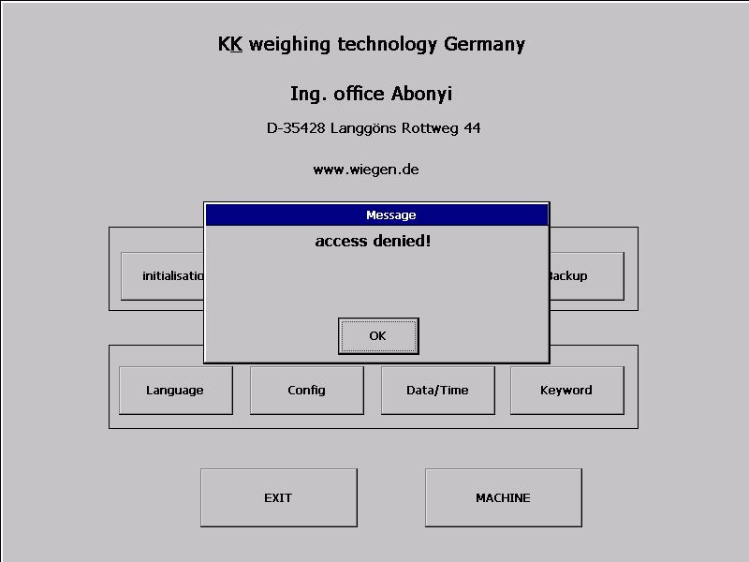

Push the button KEYWORD to activate the password-menu:

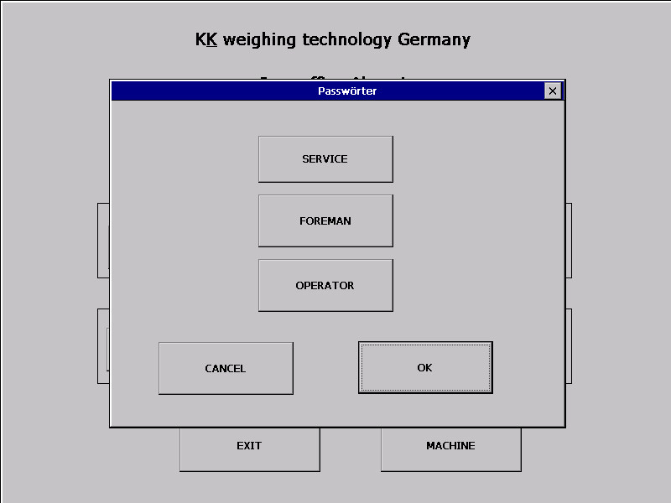

Push the accesslevel relevante button:

service = service, foreman = foreman, operator = operator …

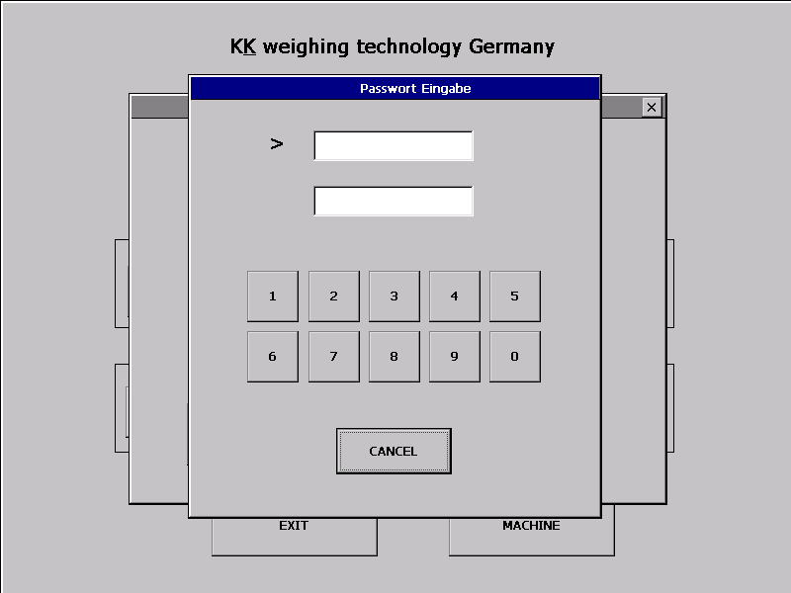

Please enter your 4-digit keyword. ( Every digit will be displayed by a star .)
If keyword-number is accepted,
you are asked whether to change your keyword or not.

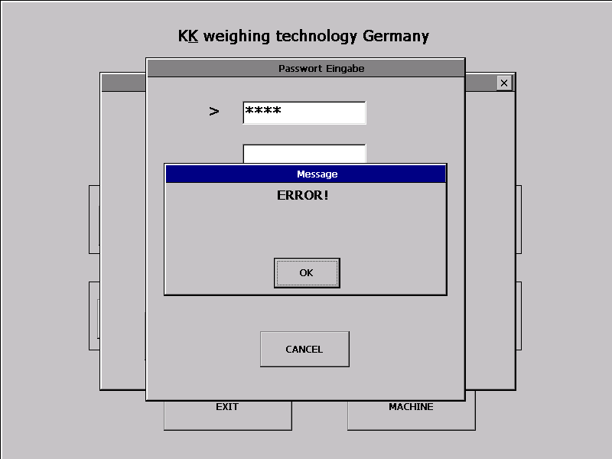

Answer with NO if you don´t want to change your keyword
and you will leave the keyword-menu automatically.
If you answer with YES the keyword-menu appears again.

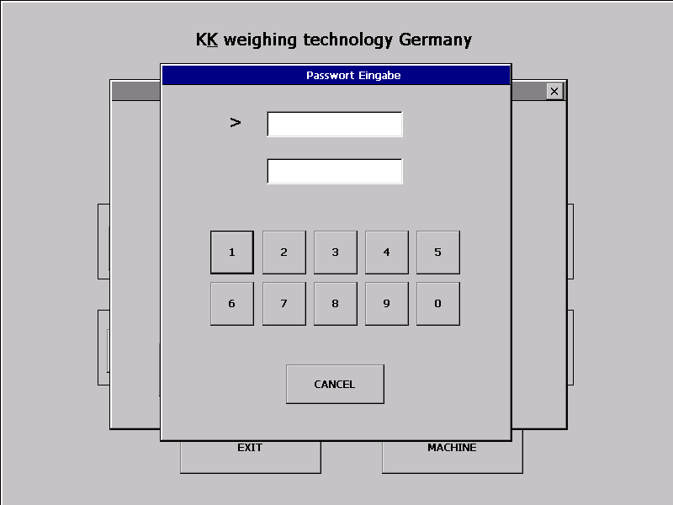

Enter your new keyword into the upper window and repeat it in the lower window.
If the two keywords agree you will leave automatically,
if not you will get an „error“-message.
After confirming the message you have to repeat the procedure.

This message also appears if you enter a not registrated or wrong keyword.

Warranties:

SERVICE free access to all functions

FOREMAN no access - to the initialization of the weighing machine - to update - menus
- to main-tare and adjustment
- to change or delete the „PROTECT“ recipes

OPERATOR access free - to start, stop, read recipes, simple- tara, and modify references

2. DATA/TIME Enter or change date or time.

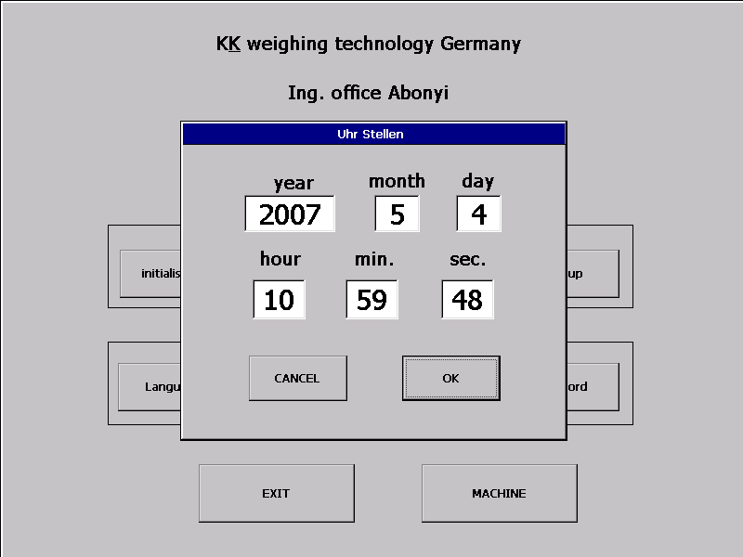

By pushing a window you can change the adjustment ( in this example : Year)
or leave the menu without a change by actuating the CANCEL button .

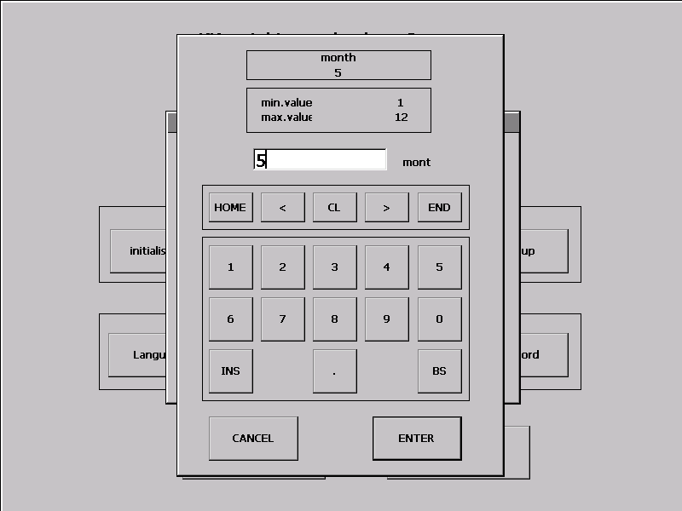

After the input push the ENTER-button to adopt the changes.

- CONFIG change or set „Windows“ settings

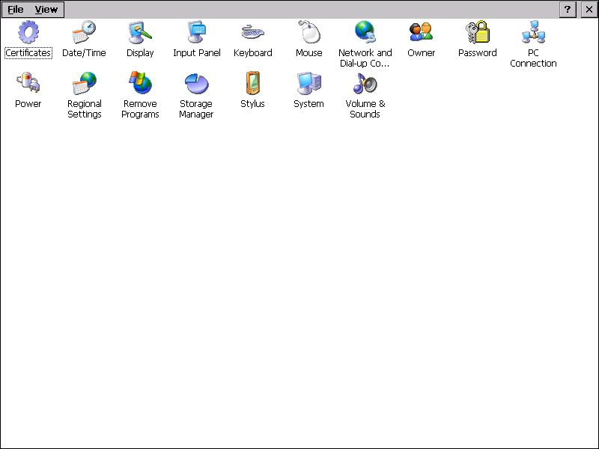

Warning! Modifications will be overwritten after Restart with Standard-values.
To set the modifications as default you have to start the programme „Rflash.exe“ once before powering down. The programme saves the changes in the flash-memory automatically.
To use this programme, you have to leave the weighing-programmes POWER-ON by pushing the CANCEL button.

To leave this side : push „file“ > „exit“.

4. Language choose language

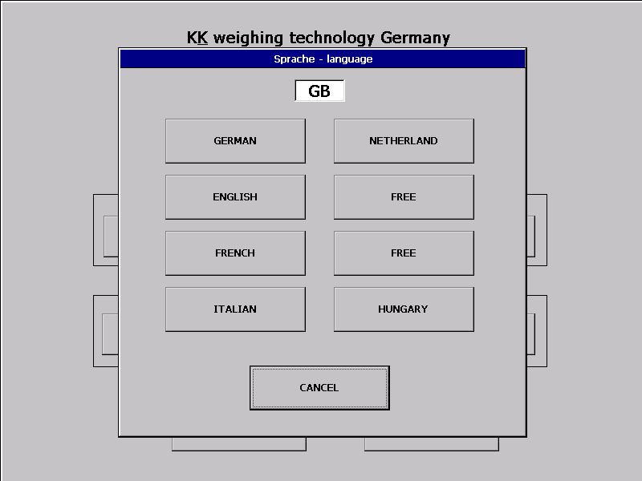

In the window, the shortcut of the chosen language appears.
By pushing the button the display-language changes.
If a language doesn't exist, an error – message is displayed.
Otherwise you will automatically return to the POWER-ON menu.

5. BACKUP backup or restore weighing references

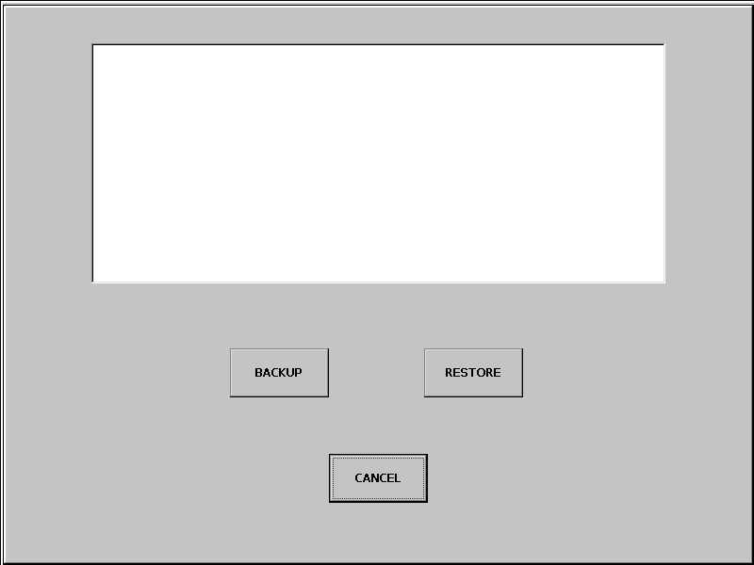

By pushing the BACKUP-button all settings are copied from the
IPC on an USB-stick.

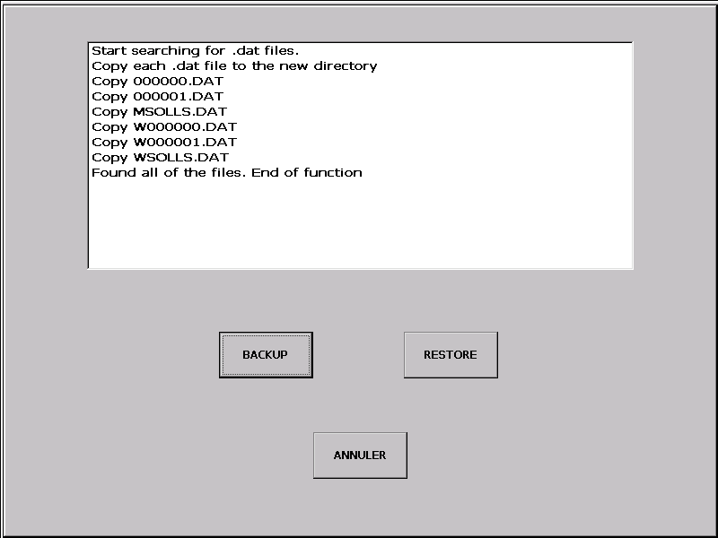

The copied files can be reimported by the RESTORE- button.

6. UPDATE SERVER Update main-programme

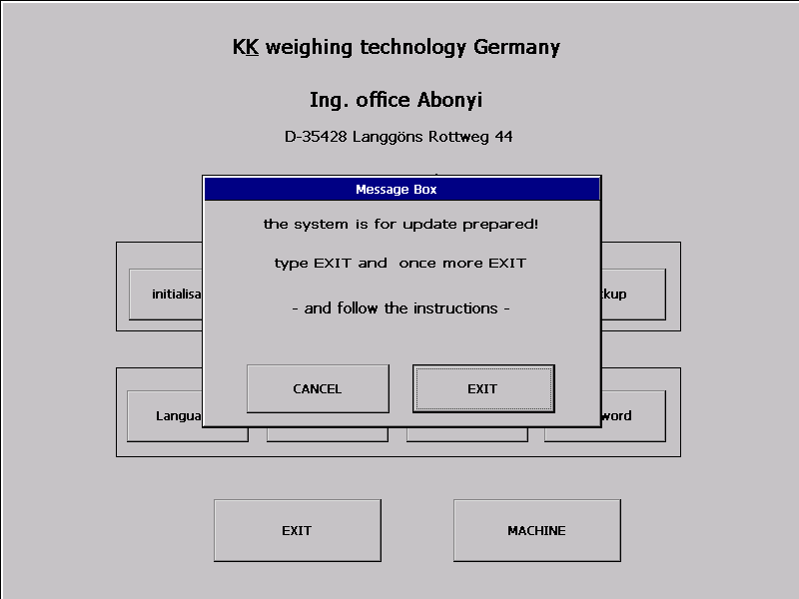

Push the button EXIT, and after returning into the POWER-ON-menu again
the button EXIT to start the update.

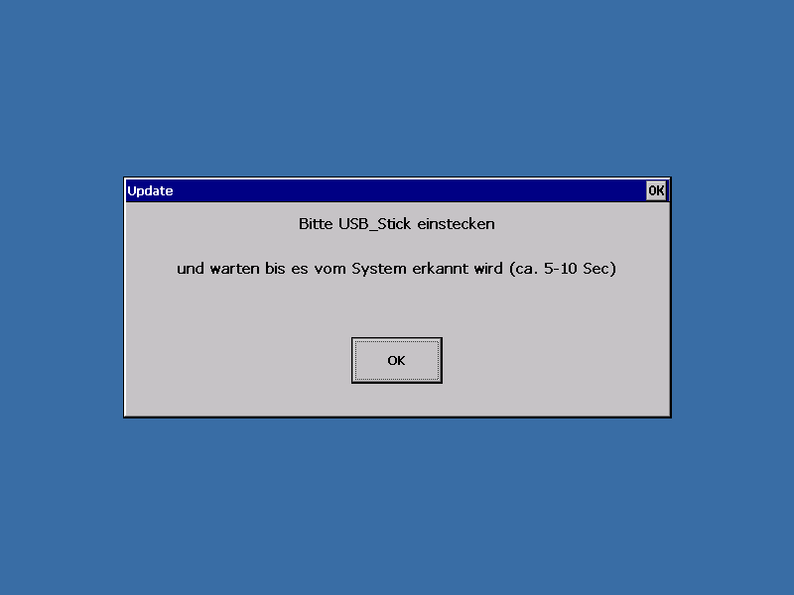

Plug in the USB - Stick and push the OK button.

During the update, the programme will inform you about the copy-procedure.

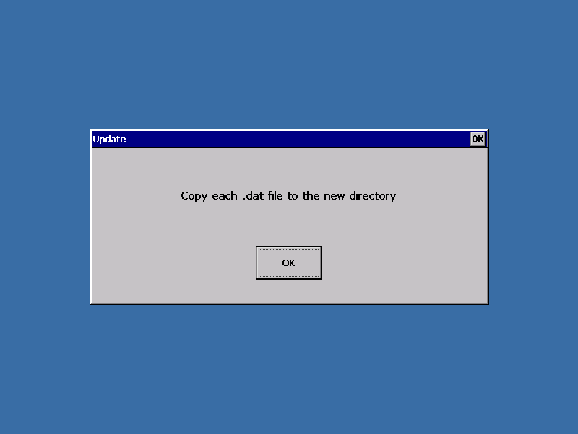

If all files were copied faultlessly, the following message appears:

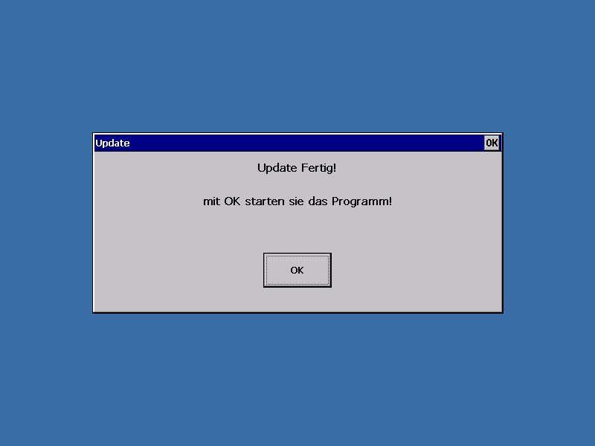

Push the button OK to start the weighing – main - programme.

7. UPDATE CLIENTS update working - units (not for the AKE-Units!)

After pushing the button UPDATE CLIENTS the programme
will import all necessary files.

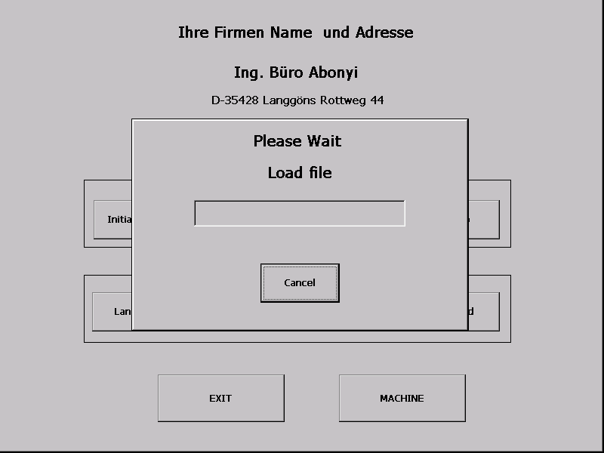

and copies them to the working-units..

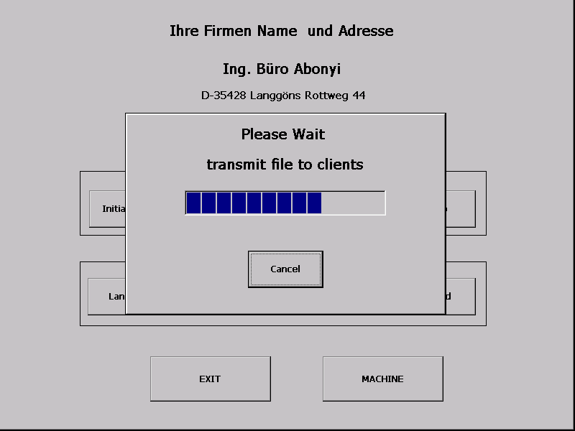

After the checkup you can restart the machine.

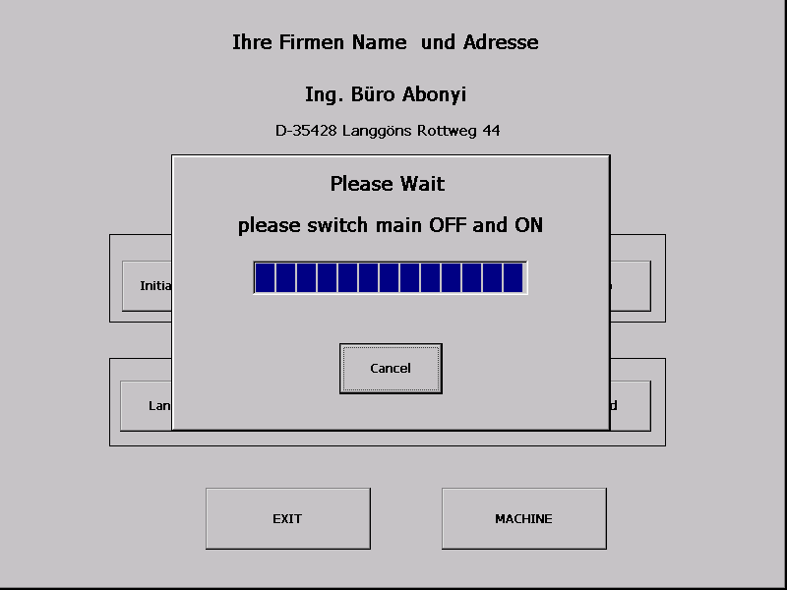
Please switch out the main switching device and on again after 10 seconds.

8. INIT Weighing-machine basic settings

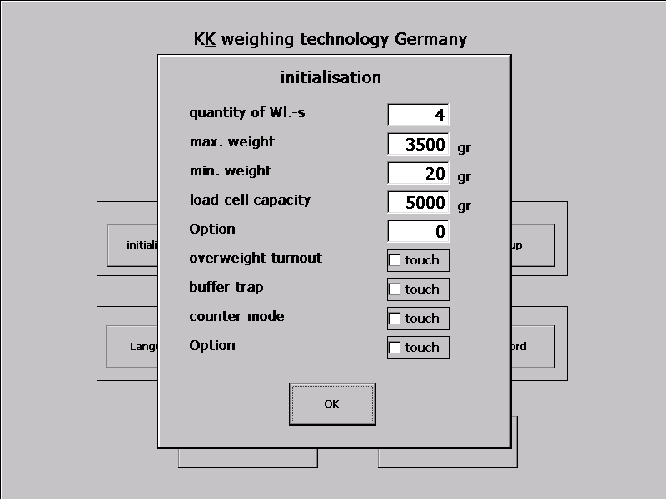

After pushing the button INITIALIZATION the menu-window to set
or change the basic settings appears.
Example: push the button „quantity of Wl-s“ and put-in the amount of weighing-lines.

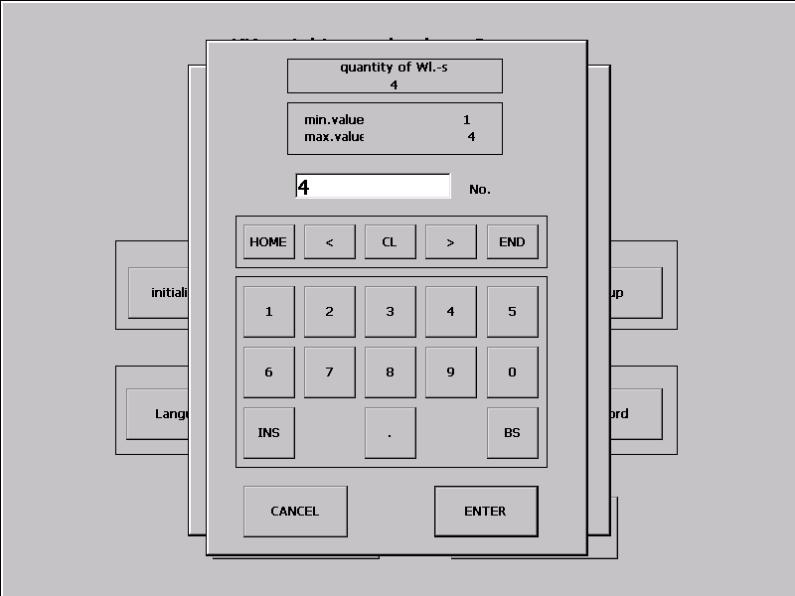

After your entry push the button ENTER to adopt it.
9. MACHINE Opens the menu of the weighing-machine

Push the button MACHINE to open the weighing-menu.
The last used settings will be adopted automatically.

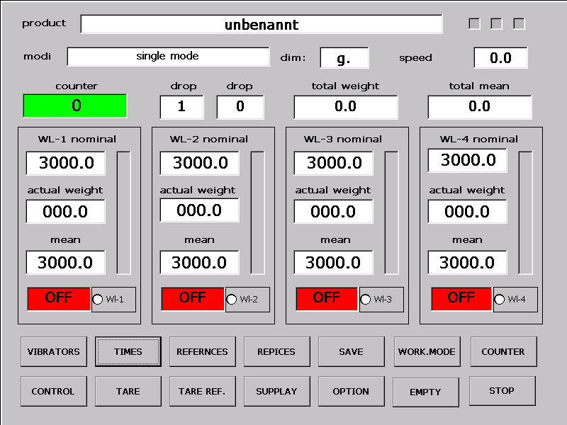

Example: Start of WL-1
To start the WL-1 with the available settings push the window STOP
( which is coloured in red now) in the WL-1 nominal frame.
The pushed red window becomes green and the text changes into ON.

10 COUNTER dropcounter settings

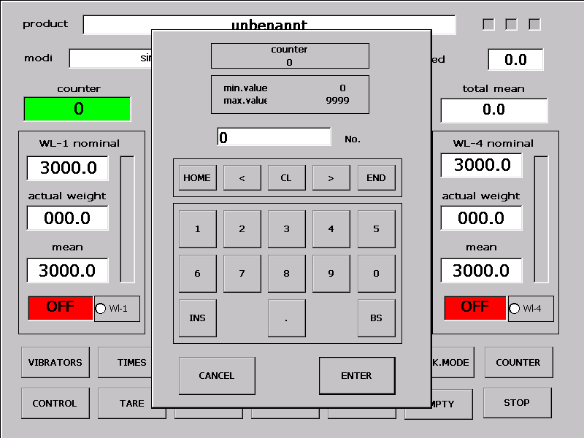

By pushing the button COUNTER the numeral keypad opens.
Insert the number of the wanted drops (0-9999) and push the button ENTER.

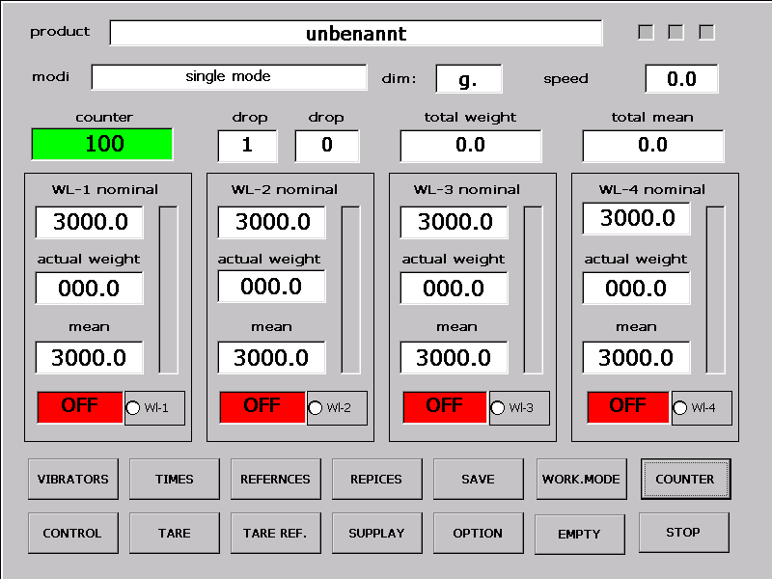

The counter will change according to your entry and the coloured window changes from red to green.
If you are logged in as a service-person you can insert a number to 9998 to leave the programme and change window settings.

11 OPERATING MODE set and change operating mode

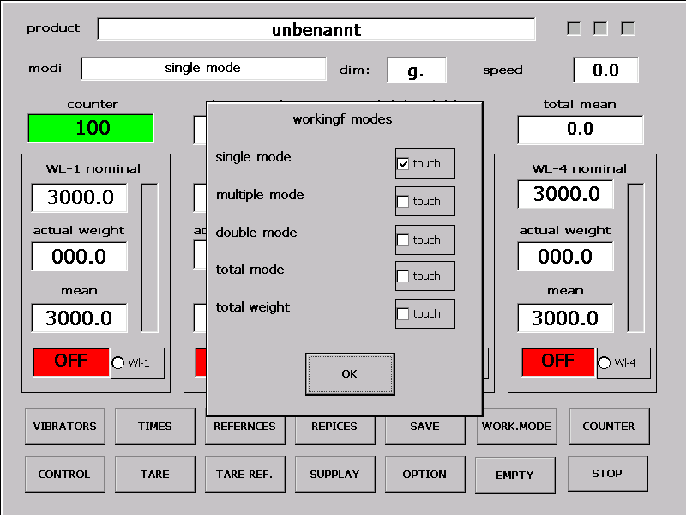

By pushing the button MODE the menu for the operating mode opens.
Only the pads which are adoptable for your weighing-system can be activated.

- Single-line weighing-machine: standard and multiple drops

- Double to fourfold weighing-machine: standard modes
total drop
total weigh modes
optional: double or multifold drop

If you selected the multifold drop you have to insert the number of drops.
Push the window Drop-Nr. and insert the number of drops in the appeared keypad.

Insert the declaration of weight as usual with the button NOMINAL as if there
was only one drop. The controller will calculate the datas for each drop.

12. RECIPES save , import , copy , change , delete recipe

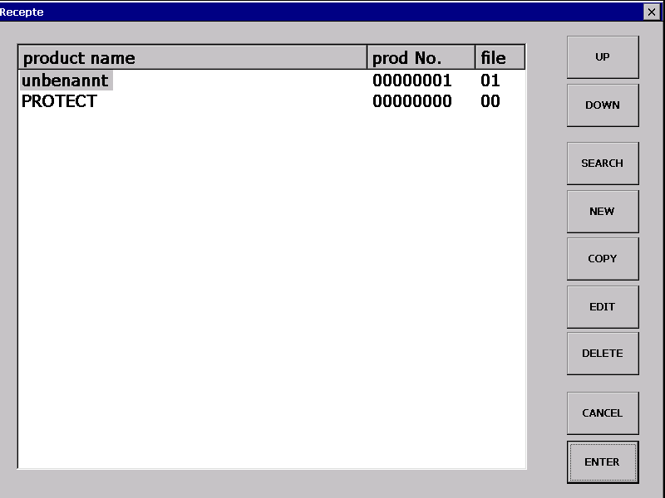

In the recipe-collection the weighing-values are allocated to a name and a number.
That makes the detection over product-name (20 letters) and/or product-number
(8- digit) possible .
All products which name starts with PROTECT are example databases
which cannot be deleted by the operator or the foreman.

A copy of this dates is possible without restrictions.
The input of the name will be infected over a alphanumeral keypad
which appears automatically if you enter , copy or change the name .
If needed , the numeral keypad will be offered automatically.

A selection can be effected by a push of the chosen entry.
over UP and DOWN or about the SEARCH function.
A product is selected if its name has a blue background.
A grey background is not an available mark.
By pushing ENTER the weighing-values for the blue-marked product
are imported into the memory.

The memory contains 100 entrys maximum in the standard version.

12.a RECIPE COPY copy the recipe

To copy an existing recipe you have to select it at first. Select the
recipe by pushing and push the button COPY .

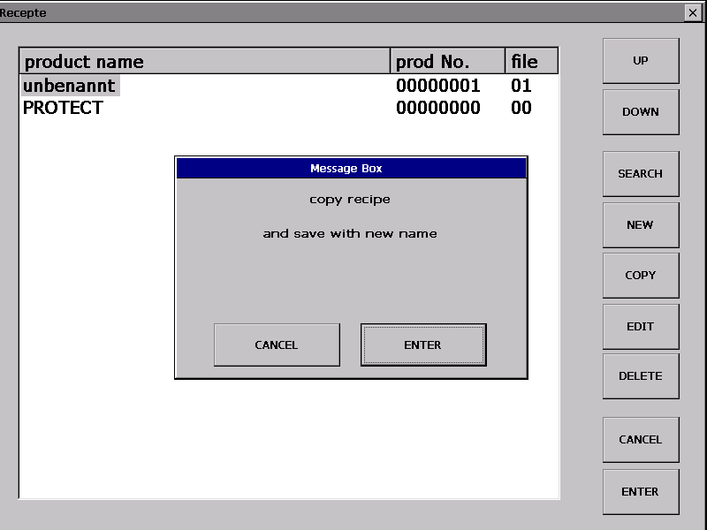

You will be asked if you really want to copy . Verify the question with ENTER
if you are sure. After the verification the alphanumeral keypad appears ,
so you can insert the name of the new entry.

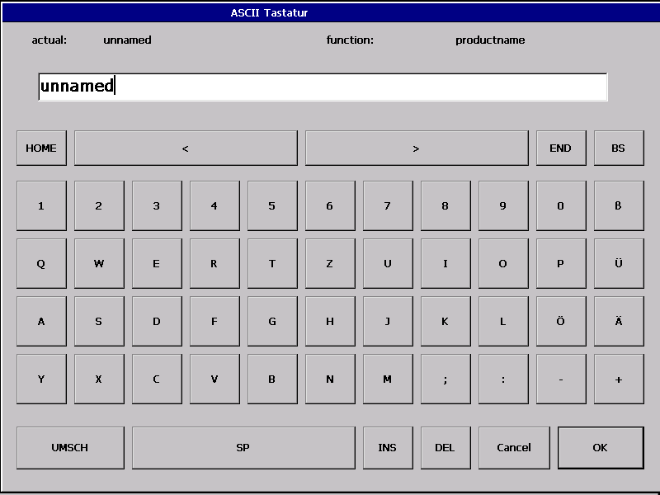

Enter the name of the new entry and verify with ENTER.

To insert the new product number ( in this example 00000009) and verify
with ENTER.

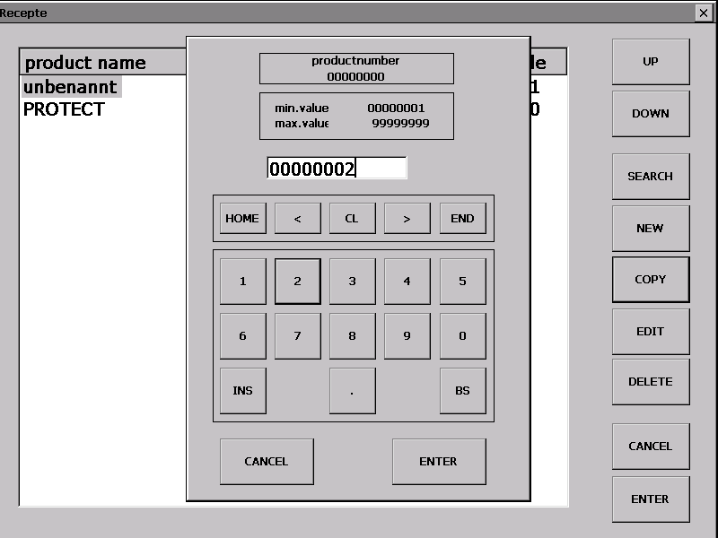

Enter the new 8-digit product-number ( in this case 00000009) and verify with ENTER.

! Warning ! Every product-number may just be inserted once. If the entered product number is already existing a message will appear and the procedure will be aborted.

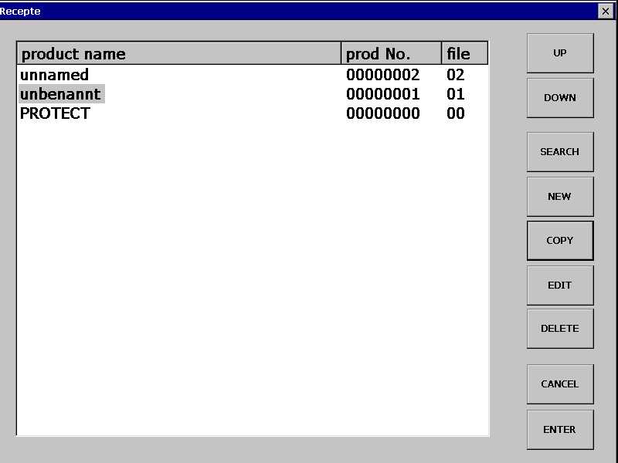

12.b RECIPE - EDIT change product-number/-name

1. Change product-name :
After pushing the button EDIT select PRODUCT NAME.

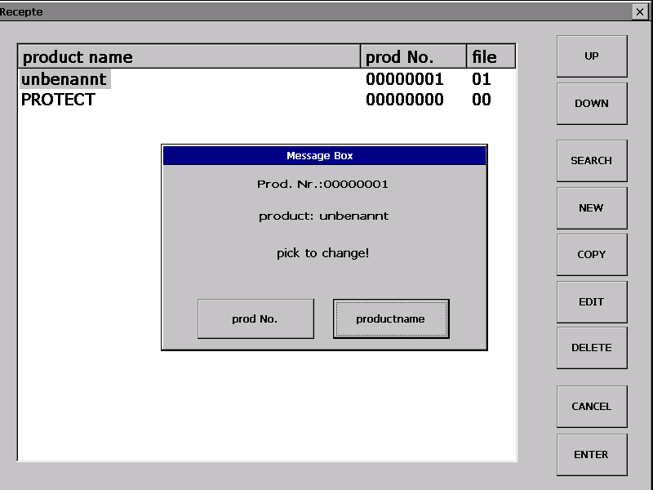

Change or enter the name and verify with ENTER.

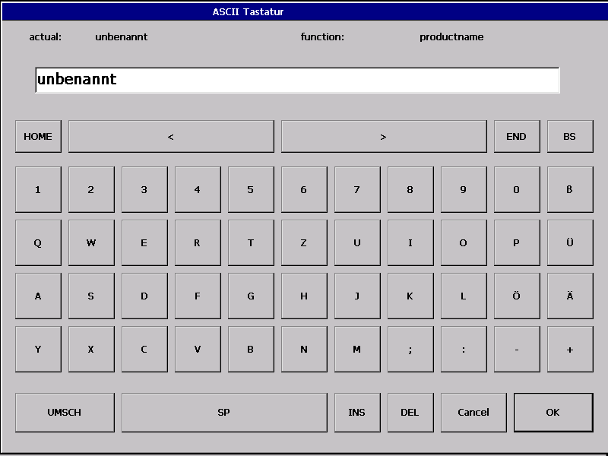

The change will immediatelly appear on the recipe-administrations main-window.

12.c Change product-number.

After pushing the button EDIT choose PRODUCT-NUMBER.

Insert the product number or change it and verify with ENTER:

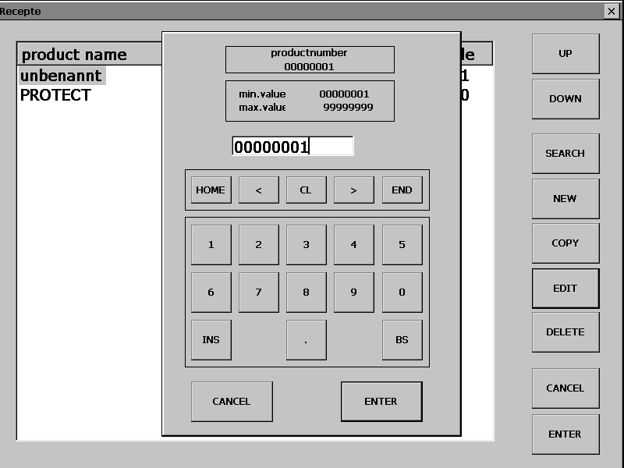

The change will immediatelly appear on the recipe-administrations main-window.

12.d PRODUKT – DELETE delete recipe including ist datas

Delete recipe : Mark the selected entry and push DEL. Verify the
security-question with ENTER or push CANCEL if you want to
stop the deleting- operation.

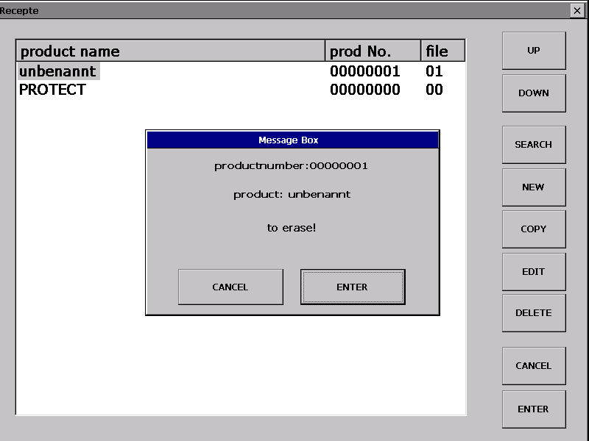

The deleted entry escapes from the recipe-administrations main window.

! Warning ! The deleting operation is irrevocable . Before you verify the deleting operation you should control if the blue-marked selection really is the right one.

To prevent this error , you should use the backup-function as often as possible.

12.e RECIPE-SEARCH
1. Searching a product-number

Push the button SEARCH.

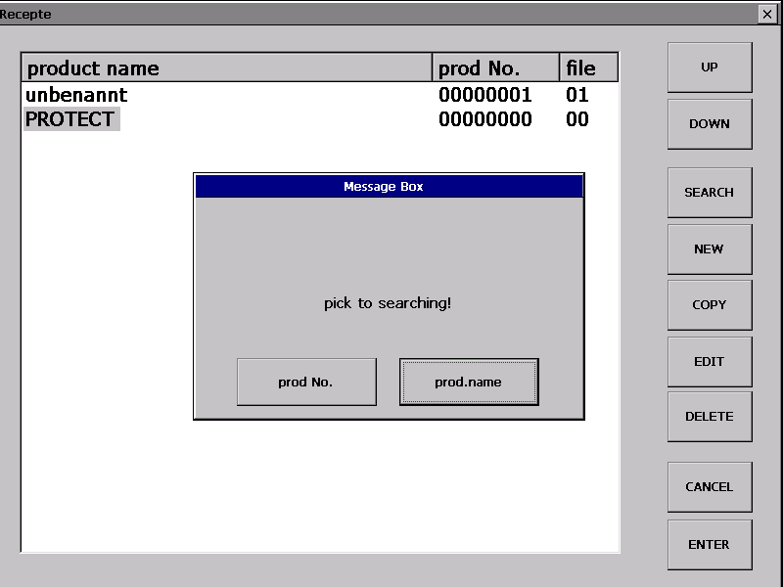

Choose PROD.-NR. and put in the searched product-number.

After pushing the ENTER-button the searched product appears blue-marked . If the product does not exist , you will get an error-message.

12.f Search for product-number

Push SEARCH and choose PROD.-NO.

Insert the name of the searched product.

The searched product appears blue-marked . If the product does not exist ,
you will get an error-message.

13. TARE-VALUES

Push the button TARE to go to this menu-window.

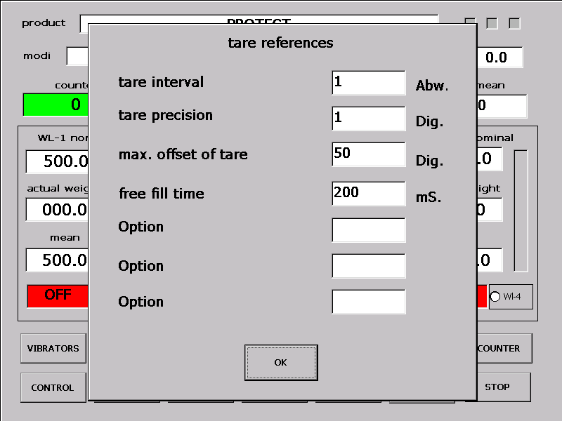

Taration-interval : Number of drops after which an auto-taration will start.

Taration-precision: The number between 0-10 regulates the taration´s accurancy .
A smaller number has a higher accuracy as consequence.

Max. Tara Offset: is not used at the AKE-unit.

Free fill-time: At the beginning of the dosing , the free-dosing time
sets the time of the uncontrolled dosage.
This function effects prohibit failures induced by vibrations
on the weighing-bowl..

The Option(s) are not used at the AKE-unit.

14. TIMES

Push the button TIMES to go to this menu-window

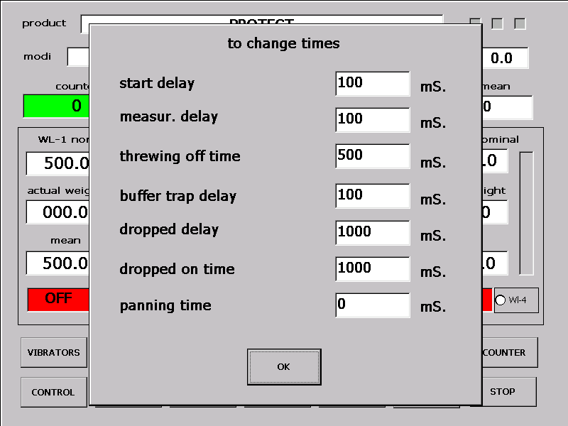

Start-delay: Time between the shutters closure on the weighing bowl to the
start of supply .Prevents dosage into a still open scale.

Measur.-delay : Time between the supply-shutters closure to
the controlling measure of the amount of product
in the weighing-bowl . This delay makes sure that also
later-arriving products are seized in the measure.

Threwing off time: Opening-time of the weighing-bowl

Buffer trap delay :Falling-time into the inter-scale

Dropped on time: Not used at the AKE-unit

Panning-time: Not used at the AKE-unit

15. SUPPLY

Push the button SUPPLY to go to this menu-window.

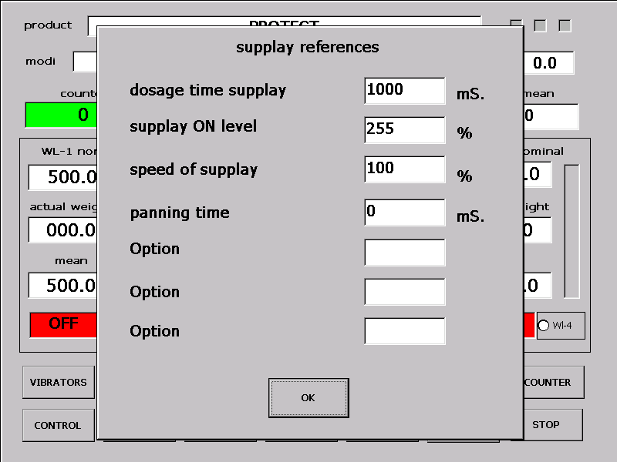

Dosing-time supply: Minimal duration of dosing

Supply to level: Value between 0-100% which starts a dosing.

Supply speed: Not used at the AKE-unit

Panning-time: Not used at the AKE-unit

Option(s): Not used at the AKE-unit

16. REFERENCE VALUES

Push the button REFERENCES to go to the menu-window .

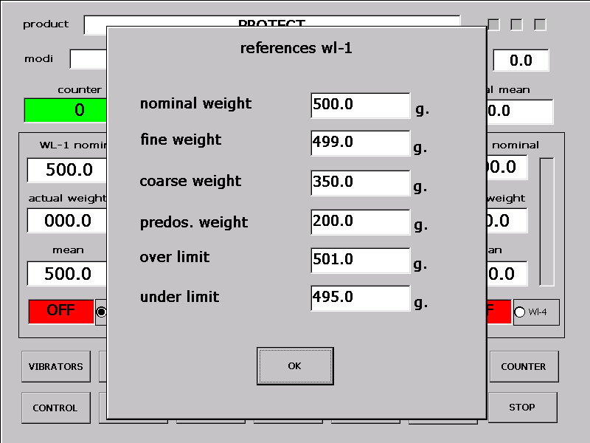

Nominal weigh: The products final weigh

Fine weight: Weighing value that starts to stop the dosage
All supply-shutters are closing.

Coarse weigh: Weighing-value that stops the coarse-weight
and starts the fine-weight.

Pre-dosing value: Some machines support a fast pre-dosage.
This is only necessary for weighing big capacities.

Upper limit : Weighing-value that induces a deflation of the weighing over
a overweight-switch.

Under limit:: (minimum final weigh)
If the final weigh is not reached after the controlling measure ,
an automatical dosage starts until the reference
weigh is reached.

17. TARE

Push the button TARE to activate this function .The status of the weighing line
intends the following activity.

- If the weighing-system is switched out, a manual taration is necessary.
After a short moment of waiting you get a message.

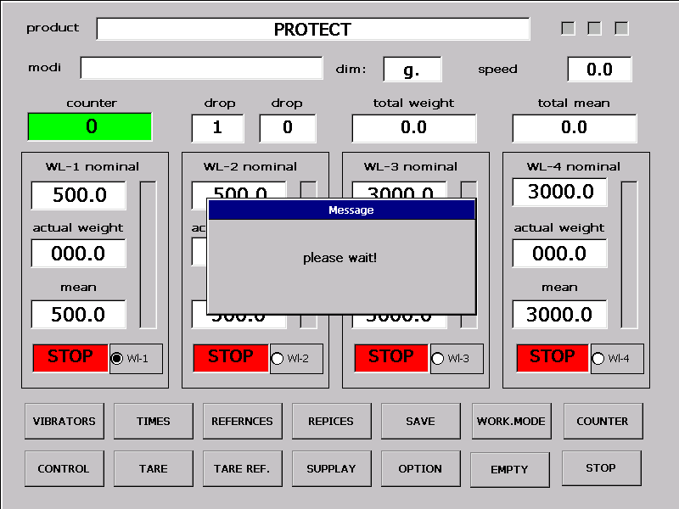

- If the marked weighing-line is active , only the tarationcounter is set new.

- EMTY

Push the button EMPTY to activate this function.

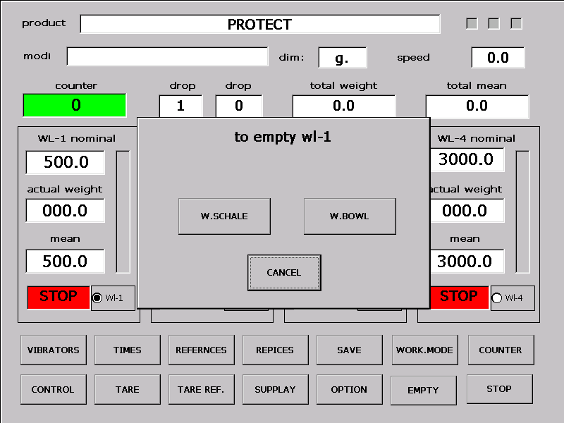

Choose between empty weighing-bowl or empty weighing-lines .

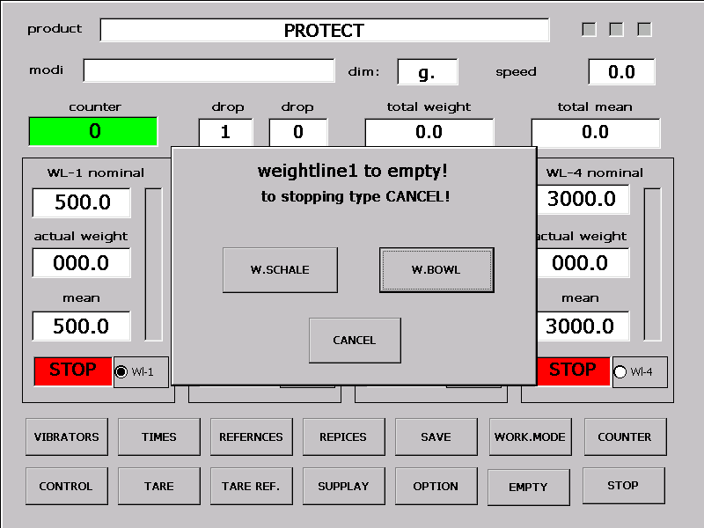

You can stop the deflation by pushing the CANCEL button.

19 ON/OFF weighing-lines start/stop

Push one of the red windows to start a weighing-line .

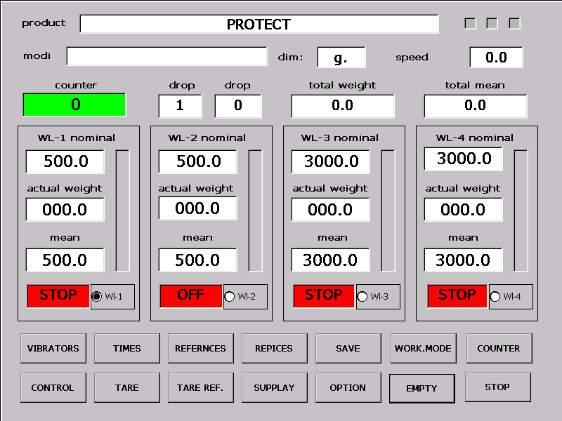

The marked window changes into a green colour and ON

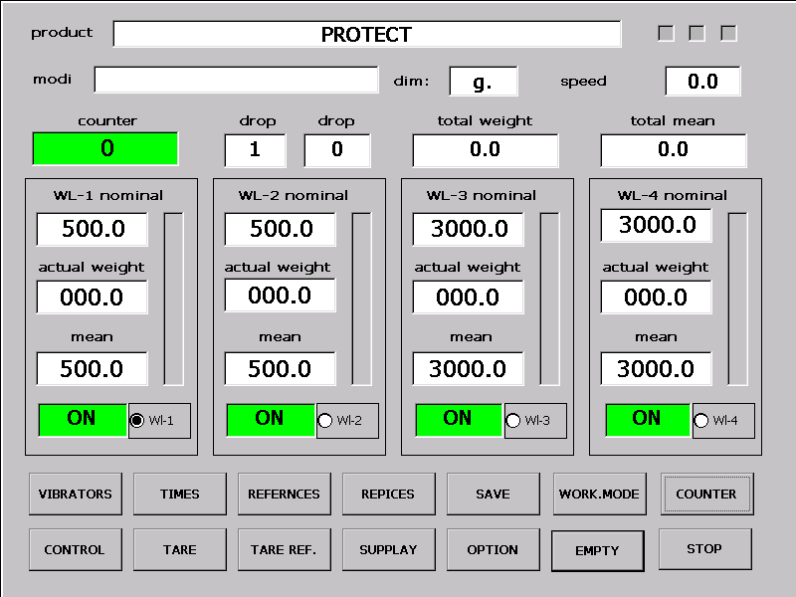

WL-1 weighing is ready . Finished-message and real value (including mean
value) have changed to the actual value.

- ACTIVITY ADVERTISEMENT

After a dropping the activity advertisement will be actualized. It shows the average of the last 100 drops.

The inferior windows show the mean values of the last 100 drops.
To delete the mean values (restart) push the according window once.
After pushing, the actual reference value until the first drop will be registerated.

21 CONTROLL controlling-menu

Push the button to go to this menu-window .

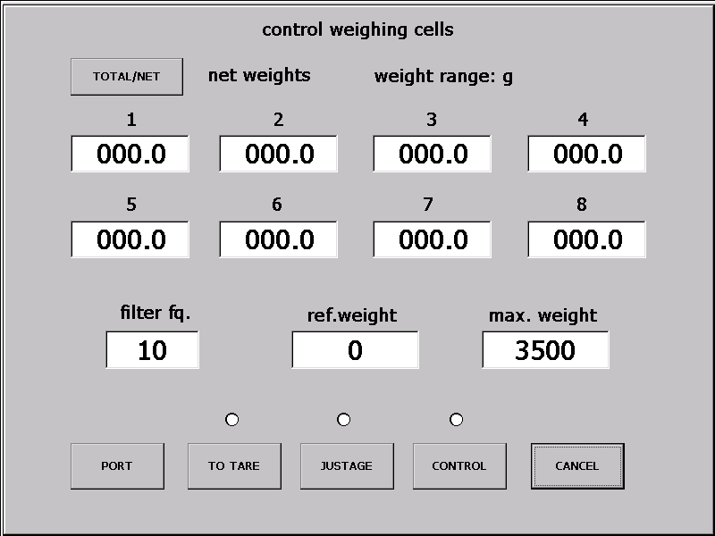

With the button TOTAL/NET you can choose between total or net display.

The corner frequency of the digital filter can linear be set between 1-50 hz
by pushing the window FILTER FR.

By pushing the button TARE a chosen weighing-line will be tared .

By pushing the button JUSTAGE a chosen weighing-line an be
justified automatically. ( at the AKE-series the function is limited
to +- 10% correction !

- Tare the justified weighing-line.
- Inscribe the calibrated weight into the window CALIBRATED WEIGHT.
- Push the button JUSTAGE
- Answer to the security question „Has the line already been tared?“
- Put the justifying-weight into the scale.
- Push the weighing-line window.
- Controll as a precaution with the controll-functon if the justification is ok.
8. If you dealt amiss in this procedure , this mistake can implicate a total error.

Justification-error:

Push the relevant window to reset the multiplier of the display manual .

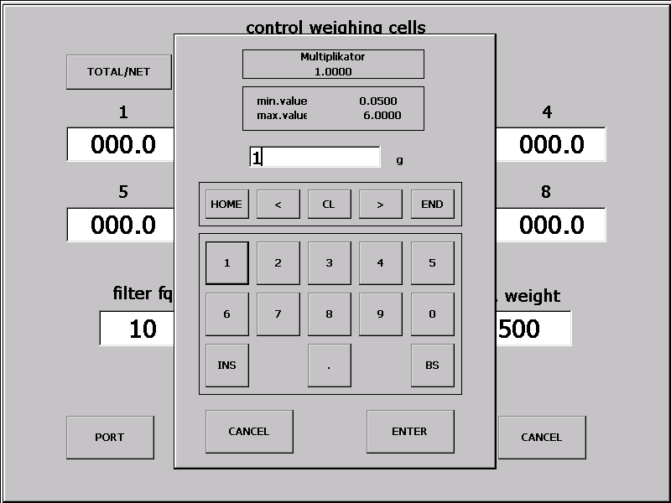

Insert the multiplier ( given by the company) over the virtual keypad , certify the input with ENTER and repeat the justificaton procedure.

As a correction , a new insert of the multiplier is also possible .To activate this function you have to be logged in as SERVICE-man.

22. INPUT-OUTPUT CONTROL

Push the button PORT in the controlling-menu to go this menu-site.

Outputs Inputs
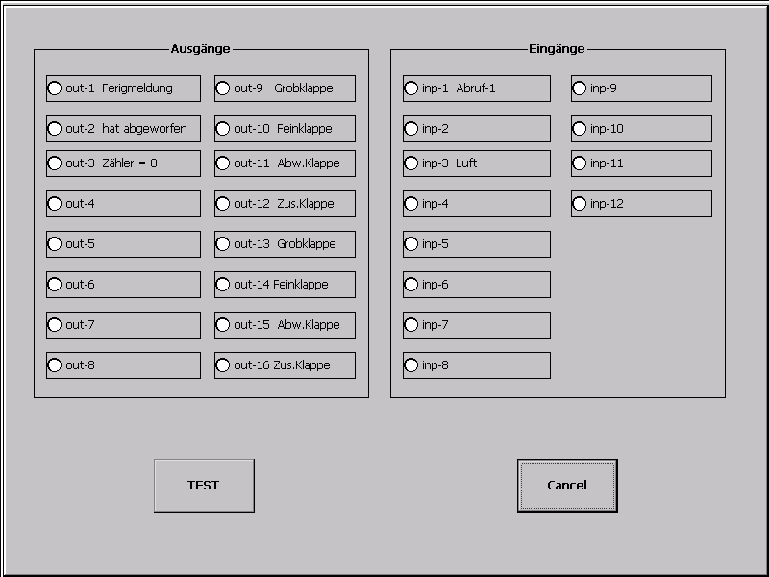

By activating a radio-control the according output is switched on or out.

By pushing the button TEST the outputs will be switched on and out one after another. .

The right key panel shows the status of the inputs.

23. Optionen Additional-functions (Optimizing, additional-functions)

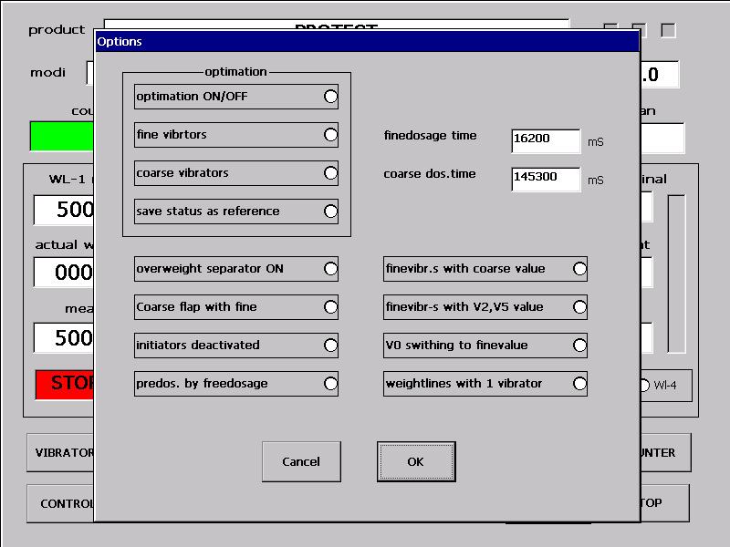

optiomation see: Description of the optimizing

standard settings are when all functions are radio button off

option: -1 „on“ ---- overweigh seperator on
-2 „on“ ---- course flap with fine
-3 „on“ ---- initiators deactivated
-4 „on“ ---- predos. By freedosage
-5 „on“ ---- finevibr.s with coarse value
-6 „on“ ---- finevibr.s with V2, V5 value
-7 „on“ ---- V0 switching to finevalue
-8 „on“ ---- weightlines with 1 vibrator

- ! the selected options are saved with the other productvalues

22 Calibrating the touch panel:

a. Push the button CONFIG on the activating- menu site.
b. Push the button STYLUS.

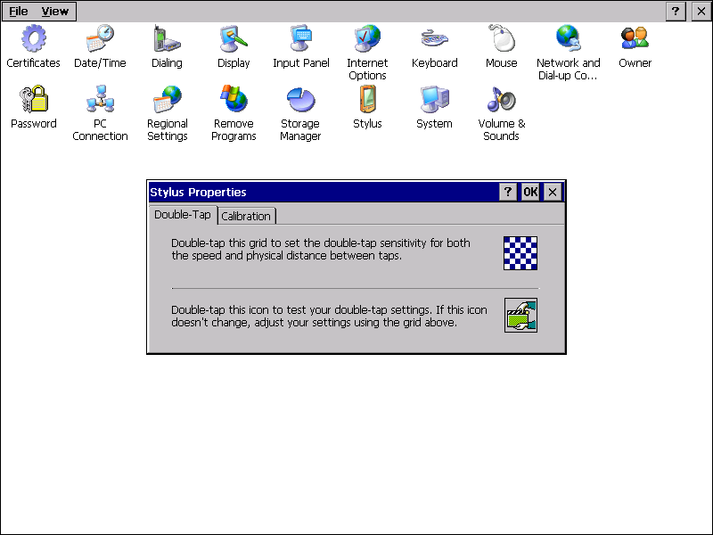

- Push the button CALIBRATION

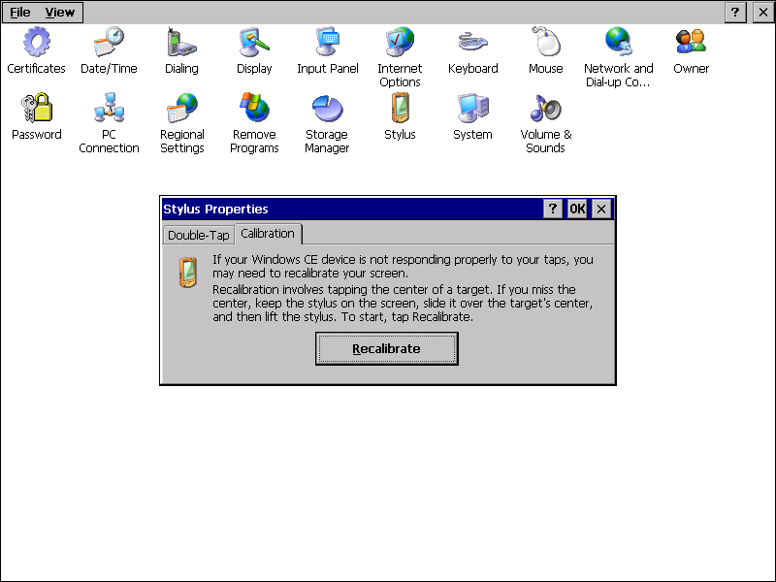

d. Push CALIBRATE

Push the cross-symbol until it moves.Outgoing from the center of the display
the displays corners are scanned.

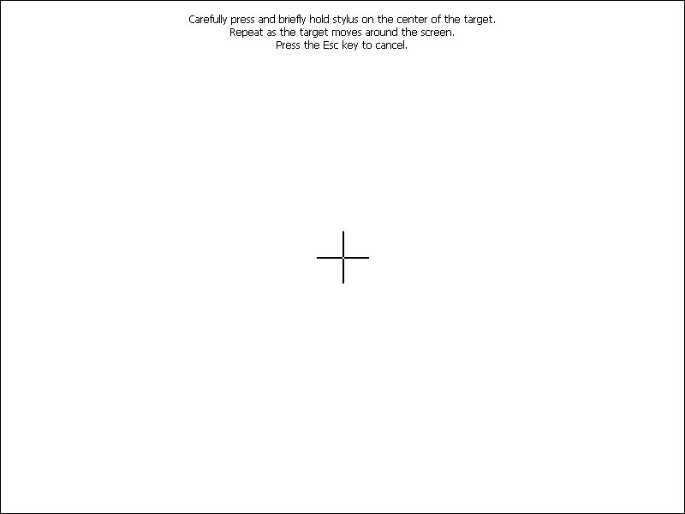

After scanning all measuring points , the cross-symbol dissappears and
the following message appears.

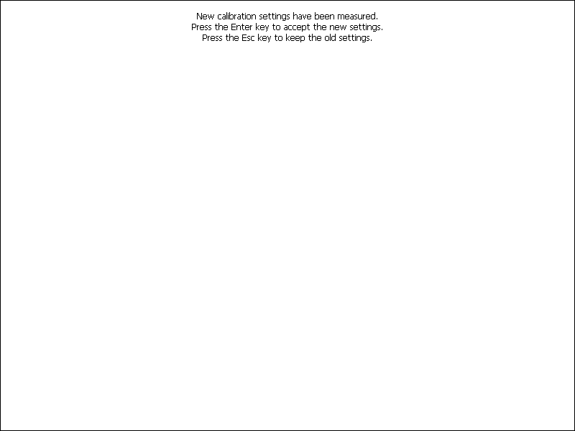

With a double-click you can leave this site .

Also leave the CONFIG-menu site and close the main programme
by pushing CANCEL on the activating-menu site.
To save the settings in the flash , open the programme „Flush.exe“

Weigh initialisation

- Change the settings on the SWITCH-ON INIT menu-site.
- Set the multiplier to MAIN MENU-CONTROL site
- Save the settings with the button SAVE on the main menu site.
- Put in all necessary reference values or copy a PROTECT-recipe.

Description of the optimizing (validity: 27.08.1995)

Limits ("d" is the multiplier in the weigher)

min. nom. poids: 200d
coarse poids: 128d
fine hyterese: 64d
poids control step upstairs: 1/64 of fine coarse different
downstairs: 1/128 of the coarse poids
vibrator-control step : 1 position ca. 0,5%
min. dosetime : 1.2 sec

exercise: adjust the fundamental adjustements of the weigher so that changments on gutterfillheight, gutteramplitude, and productproperties does not influence the finished poids.
The optimizing is no automatic initialisation or startup automatic!
It is suitable to correct the settings during the working.

operation: with the menupage which is reachable with key „Q“, at the time 2 modes
are activable

a. coarse vibrator optimization with finevibrator and
coarsepoids optimization
b. coarse vibrator optimization with coarsepoids optimization
but without finevibrator optimization

Before the optimizaton is aktivated the weigher must be setup
by hand and when power and exactnes are OK, the working
values may saved with the function "Save status as Reference"
to make them to nom. values for the otimization

On the menupage, reachable with windows of the nom.dosetime
are controlable or changeable by smal steps.

work: the dosespeeds of the doseunits will be controled.

the coarse dosespeed will be controled with +/-3% precission and
the fine dosespeed will be controled with +/- 5% precission

coarse dose fine dose

shorter -3% shorter -5% -> coarse vibration decreases
shorter -3% in the range -> coarse vibration decreases
shorter -3% longer +5% -> coarse poids increases
-----------------------------------------------------------------------------------------------
in the range shorter -5% -> a. fine vibration decreases
b. coarse poids decreases
in the range in the range -> fine poids are corrected
in the range longer +5% -> a. fine vibration increases
b. coarse poids increases
----------------------------------------------------------------------------------------------

longer +3% shorter -5% -> coarse poids decreases
longer +3% in the range -> coarse vibration increases
longer +3% longer +5% -> coarse vibration increases

Fine poids correct:

Acttual poids

fewer then nom. Poids -> fine poids = fine poids + (nom.poids – act.poids)/2
more than nom. poids -> fine poids = fine poids - (act.poids –
nom.poids)/2
in range +/- 1 digit -> no adjusting

remember:

When big changes happens on the convey to product (silo empty, matarial blockage etc.)
switch the optimizing immediately off, because it trys to correct the errors with too
big adjustements.

Stop the weight lines only in emegency cases because the folowed step after switching on is corrupt ! If desired switch the weight line with the switch off function „A“ off. In this case
the weightline stops afte finished the dose.

Change any adjusting values (nominal poids, vobrator adjustments) only while the optimizing is switched off!

When silo is empty or not completly full (example empty working) switch the optimizing off.

Do not tuch the weightheads while optimizing runs! (in other cases also not recommendable

The productmemory saves the nominal values for optimizing but
switches them not on
at a product changing. This must be done manualy after starting and
opening the silo!

tip: when the optimizing function has changed the nom. values with wrong values
(expl. convey to product disturbs) so you can react the old values with a productchange.

